**Deons Longitudinal Network Analysis**

#Load required packages

library(bootnet)

library(networktools)

library(NetworkComparisonTest)

library(qgraph)

{r echo=FALSE, warning=FALSE, error=FALSE}

Part 1: First Time point

#Load data of first network "Time1" (I just used haven)

#Assign names to the nodes in the first network

names1 <- c("IGD1", "IGD2", "IGD3", " IGD4", " IGD5", "IGD6", "IGD7", "IGD8", "IGD9", "Depression", "Anxiety", "Stress")

#Estimate network using default methods

network1 <- estimateNetwork(Time_Point_1, default="EBICglasso")  
  
#group DASS and BSMAS nodes

groups1=list("IGD"=c(1:9), "Distress"=c(10:12))

#Estimate Network Stability by bootstrapping network

b1 <- bootnet(network1, boots=1000, statistics=c("strength", "expectedInfluence", "betweenness", "closeness", "edge"))

b2 <- bootnet(network1, boots=1000, type="case", statistics=c("strength", "expectedInfluence", "betweenness", "closeness", "edge"))

#Get centrality stability coefficient

corStability(b2)

Maximum drop proportions to retain correlation of 0.7 in at least 95% of the samples:

Maximum drop proportions to retain correlation of 0.7 in at least 95% of the samples:

betweenness: 0.128

- For more accuracy, run bootnet(..., caseMin = 0.05, caseMax = 0.206)

closeness: 0.439

- For more accuracy, run bootnet(..., caseMin = 0.361, caseMax = 0.517)

edge: 0.749 (CS-coefficient is highest level tested)

- For more accuracy, run bootnet(..., caseMin = 0.673, caseMax = 1)

expectedInfluence: 0.673

- For more accuracy, run bootnet(..., caseMin = 0.595, caseMax = 0.749)

strength: 0.673

- For more accuracy, run bootnet(..., caseMin = 0.595, caseMax = 0.749)

Accuracy can also be increased by increasing both 'nBoots' and 'caseN'.

#Save centrality stability graphs

pdf("CentrStability1.pdf")

plot(b2)

dev.off()

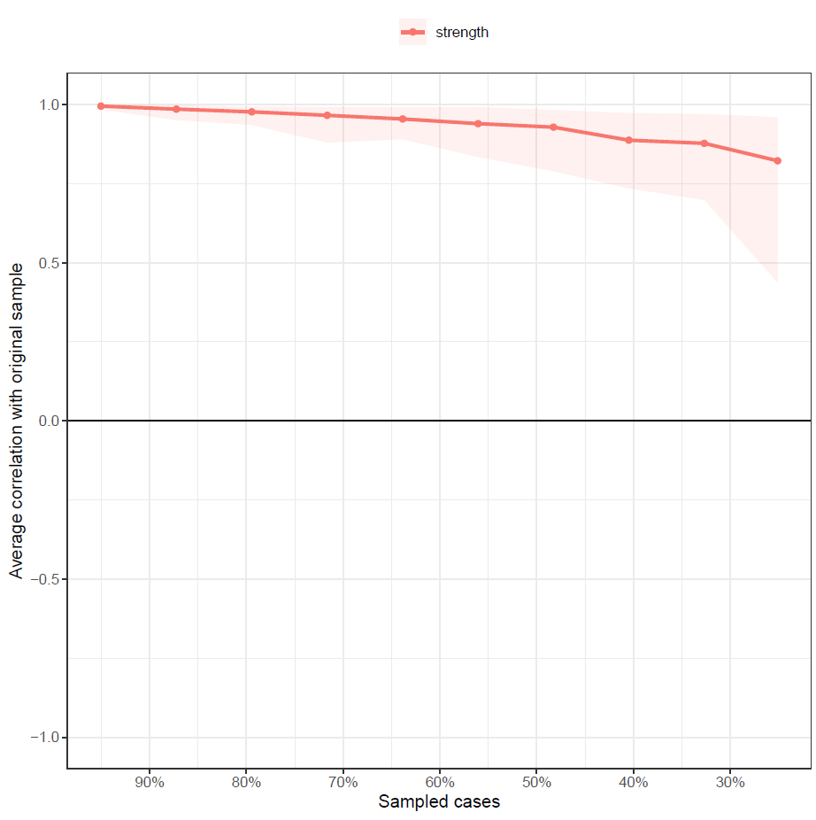

pdf("ExpectStability1.pdf")

plot(b2, “expectedInfluence”)

dev.off()

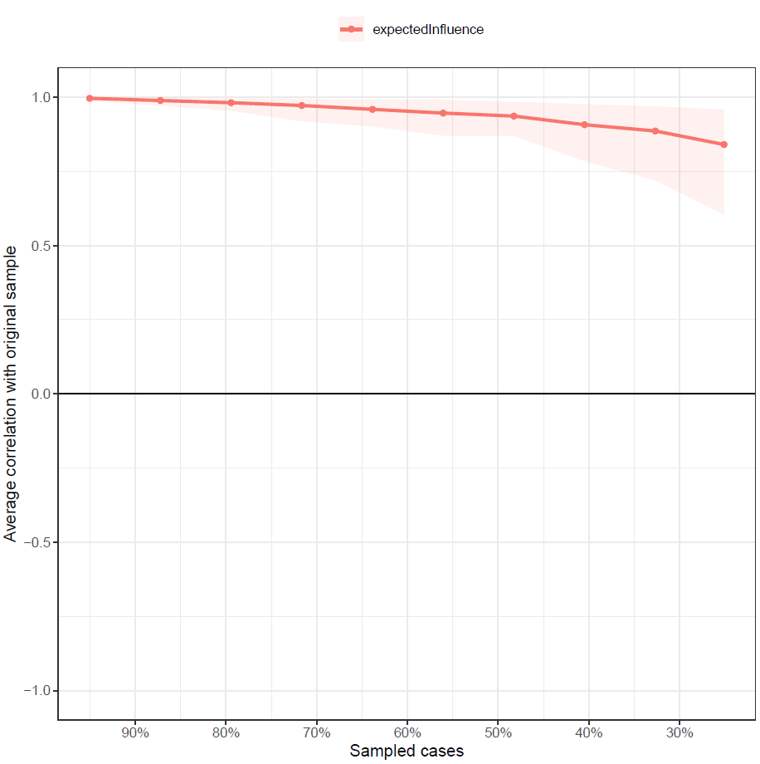

pdf("betweenStability1.pdf")

plot(b2, "betweenness")  
dev.off()

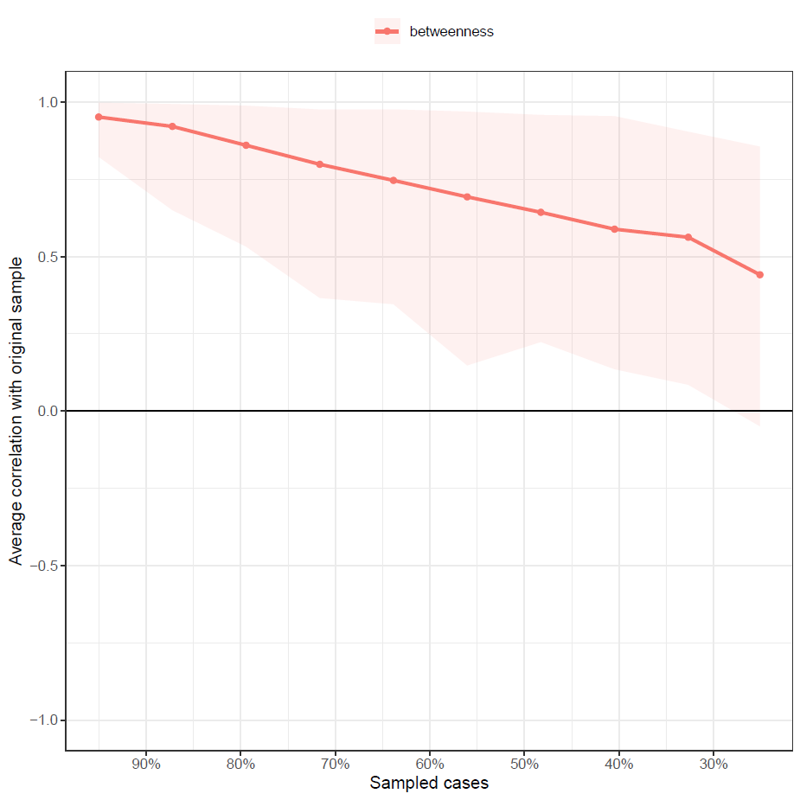

pdf("closeStability1.pdf")

plot(b2, "closeness")

dev.off()

#Expected Influence Centrality Diff Test, saved as pdf

pdf("ExpectedDifference1.pdf")

plot(b1, "expectedInfluence", order="sample", labels=TRUE)

dev.off()

#Edge Stability Graph saved as pdf

pdf("EdgeStability1.pdf")

plot(b1, labels = FALSE, order = "sample")

dev.off()

#Edge weights stability test saved as pdf

pdf("EdgeDifftest1.pdf")

plot(b1, "edge", plot="difference", onlyNonZero=TRUE, order = "sample")

dev.off()

#create strength/EI centrality plots and save as pdf

pdf("EDPlot1.pdf", width=5)

c1 <- centralityPlot(network1, include = c("ExpectedInfluence"), orderBy ="default")

dev.off()

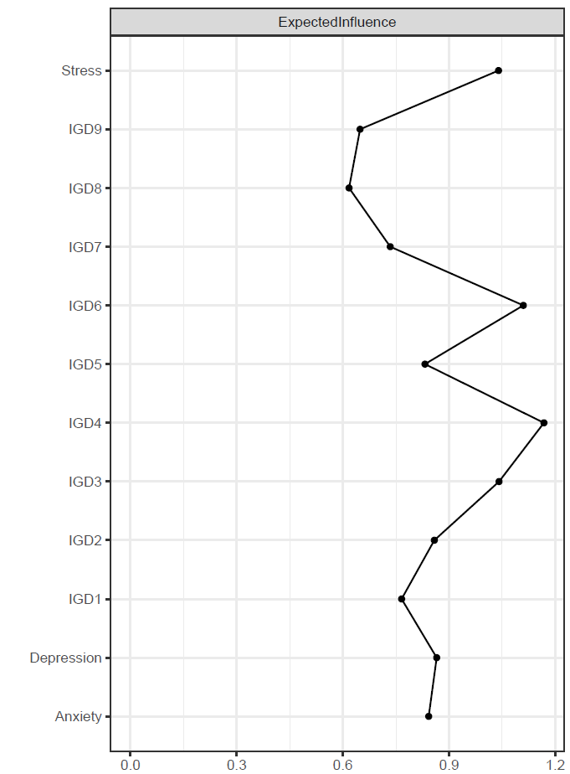

pdf("CentralityPlot1.pdf", width=5)

c2 <- centralityPlot(network1, include = c("Betweenness", "Closeness"), orderBy ="default")

dev.off()

#create a plot featuring these groups and make it a pdf

pdf("plot1.pdf")

plot1 <- plot(network1, layout="spring", vsize=6, border.color="black", groups=groups1, color=c('lightblue', 'orange'))

dev.off()

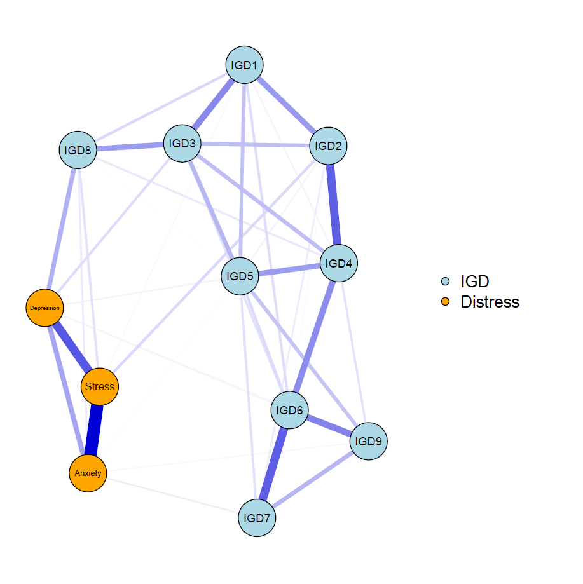

#save centrality values as a excel file

Centrality1 <- centralityTable(network1)

write.csv(Centrality1, "Centrality1.csv")

|  |  |  |  |  |  |
| --- | --- | --- | --- | --- | --- |
|  | graph | type | node | measure | value |
| 1 | graph 1 | NA | IGD1 | Betweenness | -1.00338 |
| 2 | graph 1 | NA | IGD2 | Betweenness | 1.068109 |
| 3 | graph 1 | NA | IGD3 | Betweenness | 0.679706 |
| 4 | graph 1 | NA | IGD4 | Betweenness | 1.974384 |
| 5 | graph 1 | NA | IGD5 | Betweenness | -0.61497 |
| 6 | graph 1 | NA | IGD6 | Betweenness | 0.809174 |
| 7 | graph 1 | NA | IGD7 | Betweenness | -1.00338 |
| 8 | graph 1 | NA | IGD8 | Betweenness | 0.161835 |
| 9 | graph 1 | NA | IGD9 | Betweenness | -1.00338 |
| 10 | graph 1 | NA | Depression | Betweenness | -0.4855 |
| 11 | graph 1 | NA | Anxiety | Betweenness | -1.00338 |
| 12 | graph 1 | NA | Stress | Betweenness | 0.42077 |
| 13 | graph 1 | NA | IGD1 | Closeness | 0.310523 |
| 14 | graph 1 | NA | IGD2 | Closeness | 1.475665 |
| 15 | graph 1 | NA | IGD3 | Closeness | 1.131893 |
| 16 | graph 1 | NA | IGD4 | Closeness | 1.479861 |
| 17 | graph 1 | NA | IGD5 | Closeness | 0.283646 |
| 18 | graph 1 | NA | IGD6 | Closeness | 0.151716 |
| 19 | graph 1 | NA | IGD7 | Closeness | -0.86908 |
| 20 | graph 1 | NA | IGD8 | Closeness | 0.152879 |
| 21 | graph 1 | NA | IGD9 | Closeness | -0.94052 |
| 22 | graph 1 | NA | Depression | Closeness | -0.99073 |
| 23 | graph 1 | NA | Anxiety | Closeness | -1.33539 |
| 24 | graph 1 | NA | Stress | Closeness | -0.85046 |
| 25 | graph 1 | NA | IGD1 | Strength | -0.48092 |
| 26 | graph 1 | NA | IGD2 | Strength | -0.13085 |
| 27 | graph 1 | NA | IGD3 | Strength | 0.89014 |
| 28 | graph 1 | NA | IGD4 | Strength | 1.59777 |
| 29 | graph 1 | NA | IGD5 | Strength | -0.2788 |
| 30 | graph 1 | NA | IGD6 | Strength | 1.272515 |
| 31 | graph 1 | NA | IGD7 | Strength | -0.82645 |
| 32 | graph 1 | NA | IGD8 | Strength | -1.47553 |
| 33 | graph 1 | NA | IGD9 | Strength | -1.30198 |
| 34 | graph 1 | NA | Depression | Strength | -0.09371 |
| 35 | graph 1 | NA | Anxiety | Strength | -0.21956 |
| 36 | graph 1 | NA | Stress | Strength | 1.047373 |
| 37 | graph 1 | NA | IGD1 | ExpectedInfluence | -0.6232 |
| 38 | graph 1 | NA | IGD2 | ExpectedInfluence | -0.10387 |
| 39 | graph 1 | NA | IGD3 | ExpectedInfluence | 0.923774 |
| 40 | graph 1 | NA | IGD4 | ExpectedInfluence | 1.636019 |
| 41 | graph 1 | NA | IGD5 | ExpectedInfluence | -0.25279 |
| 42 | graph 1 | NA | IGD6 | ExpectedInfluence | 1.308643 |
| 43 | graph 1 | NA | IGD7 | ExpectedInfluence | -0.80401 |
| 44 | graph 1 | NA | IGD8 | ExpectedInfluence | -1.45733 |
| 45 | graph 1 | NA | IGD9 | ExpectedInfluence | -1.28264 |
| 46 | graph 1 | NA | Depression | ExpectedInfluence | -0.06649 |
| 47 | graph 1 | NA | Anxiety | ExpectedInfluence | -0.19316 |
| 48 | graph 1 | NA | Stress | ExpectedInfluence | 0.915056 |

#construct a partial correlation matrix

edges1<-getWmat(network1)

write.csv(edges1, "edges1.csv")

|  |  |  |  |  |  |  |  |  |  |  |  |  |
| --- | --- | --- | --- | --- | --- | --- | --- | --- | --- | --- | --- | --- |
|  | IGD1 | IGD2 | IGD3 | IGD4 | IGD5 | IGD6 | IGD7 | IGD8 | IGD9 | Depression | Anxiety | Stress |
| IGD1 | 0 | 0.217942 | 0.254477 | 0.024549 | 0.131687 | 0.071065 | 0 | 0.081 | 0 | 0 | 0 | -0.01486 |
| IGD2 | 0.217942 | 0 | 0.140786 | 0.347075 | 0.024046 | 0.008055 | 0.038504 | 0 | 0 | 0 | 0 | 0.081887 |
| IGD3 | 0.254477 | 0.140786 | 0 | 0.140171 | 0.155976 | 0.06527 | 0 | 0.211871 | 0 | 0.072651 | 0 | 0 |
| IGD4 | 0.024549 | 0.347075 | 0.140171 | 0 | 0.213661 | 0.246607 | 0.088384 | 0.047314 | 0.060211 | 0 | 0 | 0 |
| IGD5 | 0.131687 | 0.024046 | 0.155976 | 0.213661 | 0 | 0.079856 | 0.064788 | 0.001663 | 0.127104 | 0.026186 | 0.006823 | 0 |
| IGD6 | 0.071065 | 0.008055 | 0.06527 | 0.246607 | 0.079856 | 0 | 0.350815 | 0 | 0.265907 | 0.022129 | 0 | 0 |
| IGD7 | 0 | 0.038504 | 0 | 0.088384 | 0.064788 | 0.350815 | 0 | 0 | 0.156158 | 0 | 0.03503 | 0 |
| IGD8 | 0.081 | 0 | 0.211871 | 0.047314 | 0.001663 | 0 | 0 | 0 | 0 | 0.170036 | 0.042843 | 0.062669 |
| IGD9 | 0 | 0 | 0 | 0.060211 | 0.127104 | 0.265907 | 0.156158 | 0 | 0 | 0.021188 | 0.017923 | 0 |
| Depression | 0 | 0 | 0.072651 | 0 | 0.026186 | 0.022129 | 0 | 0.170036 | 0.021188 | 0 | 0.191293 | 0.361464 |
| Anxiety | 0 | 0 | 0 | 0 | 0.006823 | 0 | 0.03503 | 0.042843 | 0.017923 | 0.191293 | 0 | 0.54849 |
| Stress | -0.01486 | 0.081887 | 0 | 0 | 0 | 0 | 0 | 0.062669 | 0 | 0.361464 | 0.54849 | 0 |

#Estimate bridge Values for each node

bridge(plot1, communities=c('1', '1', '1', '1', '1', '1', '1', '1', '1', '2', '2', '2'), useCommunities = "all", directed = NULL, nodes = NULL)

$`Bridge Strength`

IGD1 IGD2 IGD3 IGD4 IGD5 IGD6

0.01485977 0.08188744 0.07265132 0.00000000 0.03300927 0.02212949

IGD7 IGD8 IGD9 Depression Anxiety Stress

0.03503027 0.27554905 0.03911051 0.31219131 0.10261942 0.15941639

$`Bridge Betweenness`

IGD1 IGD2 IGD3 IGD4 IGD5 IGD6

0 12 6 10 1 5

IGD7 IGD8 IGD9 Depression Anxiety Stress

0 9 0 4 0 10

$`Bridge Closeness`

IGD1 IGD2 IGD3 IGD4 IGD5 IGD6

0.06005494 0.07277072 0.07661063 0.06030818 0.05138552 0.04845773

IGD7 IGD8 IGD9 Depression Anxiety Stress

0.04257666 0.12000233 0.04136750 0.05919151 0.05410016 0.06002024

$`Bridge Expected Influence (1-step)`

IGD1 IGD2 IGD3 IGD4 IGD5 IGD6

-0.01485977 0.08188744 0.07265132 0.00000000 0.03300927 0.02212949

IGD7 IGD8 IGD9 Depression Anxiety Stress

0.03503027 0.27554905 0.03911051 0.31219131 0.10261942 0.12969685

$`Bridge Expected Influence (2-step)`

IGD1 IGD2 IGD3 IGD4 IGD5 IGD6

0.03619248 0.16571174 0.18553096 0.06923838 0.07334152 0.06403213

IGD7 IGD8 IGD9 Depression Anxiety Stress

0.08010742 0.47250275 0.07963141 0.56509168 0.28896853 0.37222858

$communities

[1] "1" "1" "1" "1" "1" "1" "1" "1" "1" "2" "2" "2"

#Set Bridge estimates as an object

bridge1 <- bridge(plot1, communities=c('1', '1', '1', '1', '1', '1', '1', '1', '1', '2', '2', '2'), useCommunities = "all", directed = NULL, nodes = NULL)

#Create bridge expected influence graph and save as a pdf

pdf("bridgeEI1.pdf, width=5")

plot(bridge1, include = "Bridge Expected Influence (1-step)", width = 5)

dev.off()

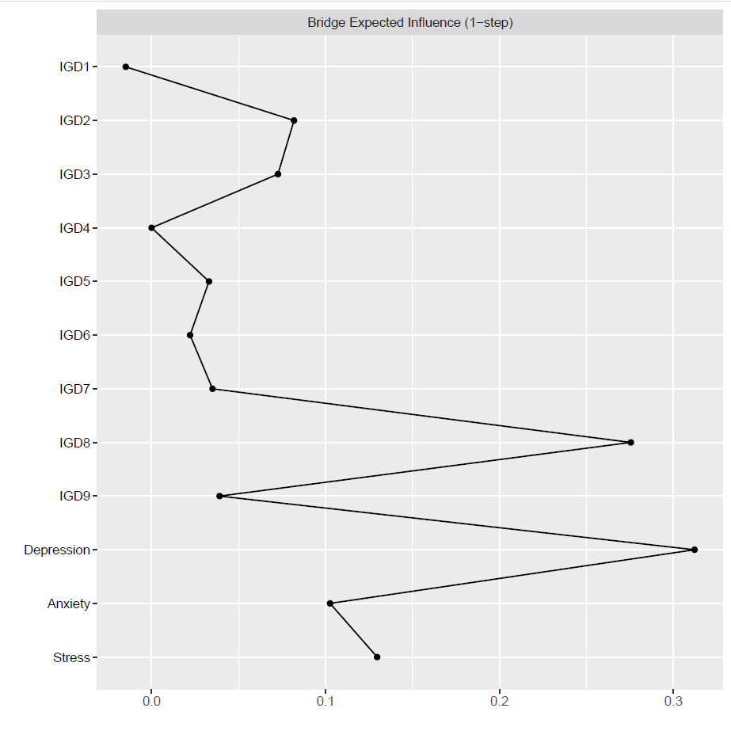

#Create an object for the Stability estimates of bridges

bridgestability1 <- bootnet(network1, boots=1000, type="case", statistics=c("bridgeStrength", "bridgeExpectedInfluence", "bridgeBetweenness", "bridgeCloseness"), communities=groups1)

#get stability coefficients of that networks bridges

corStability(bridgestability1)

Maximum drop proportions to retain correlation of 0.7 in at least 95% of the samples:

bridgeBetweenness: 0.05 (CS-coefficient is lowest level tested)

- For more accuracy, run bootnet(..., caseMin = 0, caseMax = 0.128)

bridgeCloseness: 0.361

- For more accuracy, run bootnet(..., caseMin = 0.284, caseMax = 0.439)

bridgeExpectedInfluence: 0.673

- For more accuracy, run bootnet(..., caseMin = 0.595, caseMax = 0.749)

bridgeStrength: 0.673

- For more accuracy, run bootnet(..., caseMin = 0.595, caseMax = 0.749)

Accuracy can also be increased by increasing both 'nBoots' and 'caseN'.

#And we're done with the first Network! Time to move on to number two!

Part 2: Second Time point

#Load data of second network "Time2" (I just used haven)

#Assign names to the nodes in the second network

names2 <- c("IGD1", "IGD2", "IGD3", " IGD4", " IGD5", "IGD6", "IGD7", "IGD8", "IGD9", "Depression", "Anxiety", "Stress")

#Estimate network using default methods

network2 <- estimateNetwork(Time_Point_2, default="EBICglasso")

#group DASS and BSMAS nodes

groups2=list("IGD"=c(1:9), "Distress"=c(10:12))

#Estimate Network Stability by bootstrapping network

b3 <- bootnet(network2, boots=1000, statistics=c("strength", "expectedInfluence", "betweenness", "closeness", "edge"))

b4 <- bootnet(network2, boots=1000, type="case", statistics=c("strength", "expectedInfluence", "betweenness", "closeness", "edge"))

#Get centrality stability coefficient

corStability(b4)

Maximum drop proportions to retain correlation of 0.7 in at least 95% of the samples:

betweenness: 0.05 (CS-coefficient is lowest level tested)

- For more accuracy, run bootnet(..., caseMin = 0, caseMax = 0.128)

closeness: 0.128

- For more accuracy, run bootnet(..., caseMin = 0.05, caseMax = 0.206)

edge: 0.749 (CS-coefficient is highest level tested)

- For more accuracy, run bootnet(..., caseMin = 0.673, caseMax = 1)

expectedInfluence: 0.595

- For more accuracy, run bootnet(..., caseMin = 0.517, caseMax = 0.673)

strength: 0.517

- For more accuracy, run bootnet(..., caseMin = 0.439, caseMax = 0.595)

Accuracy can also be increased by increasing both 'nBoots' and 'caseN'.

#Save centrality stability graphs

pdf("ExpectStability2.pdf")

plot(b4, “expectedInfluence”)

dev.off()

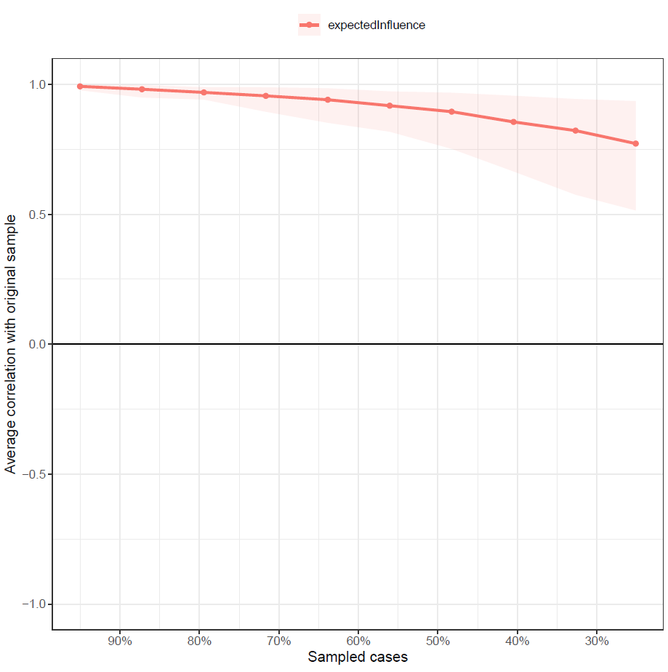

#Expected INfluence stability graph saved as pdf - Unneccessary

pdf("EIdifference2.pdf")

plot(b3, "expectedInfluence", order="sample", labels=TRUE)

dev.off()

#Edge Stability Graph saved as pdf

pdf("EdgeStability2.pdf")

plot(b3, labels = FALSE, order = "sample")

dev.off()

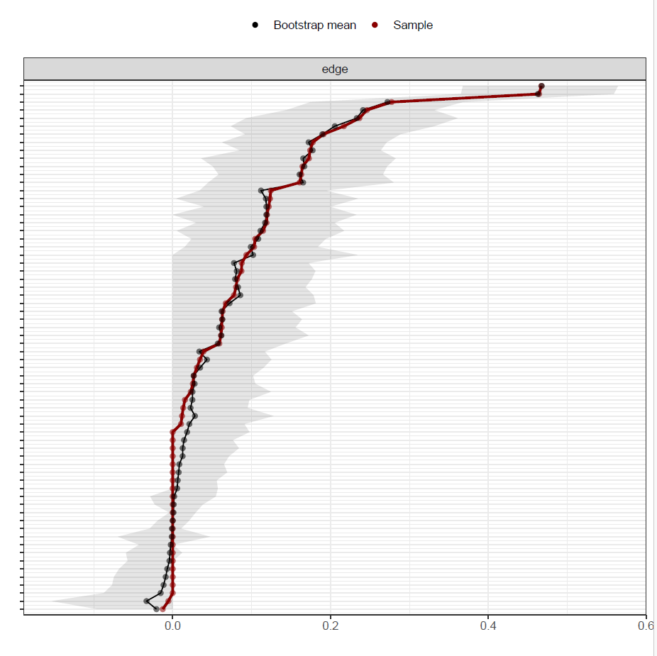

#Edge weights stability test saved as pdf

pdf("EdgeDifftest2.pdf")

plot(b3, "edge", plot="difference", onlyNonZero=TRUE, order = "sample")

dev.off()

#Save plot as a pdf with groups into set directory

pdf("plot2.pdf")

plot2 <- plot(network2, layout="spring", vsize=6, border.color="black", groups=groups2, color=c('lightblue', 'orange'))

dev.off()

#Create Expected influence plot and save as pdf

pdf("ExpectedInfluence2.pdf", width=5)

e2 <- centralityPlot(plot2, include = "ExpectedInfluence")

dev.off()

#save centrality values as a excel file

Centrality2 <- centralityTable(network2)

write.csv(Centrality2, "Centrality2.csv")

|  |  |  |  |  |  |
| --- | --- | --- | --- | --- | --- |
|  | graph | type | node | measure | value |
| 1 | graph 1 | NA | IGD1 | Betweenness | -0.66947 |
| 2 | graph 1 | NA | IGD2 | Betweenness | -0.66947 |
| 3 | graph 1 | NA | IGD3 | Betweenness | -1.26455 |
| 4 | graph 1 | NA | IGD4 | Betweenness | -0.96701 |
| 5 | graph 1 | NA | IGD5 | Betweenness | 0.520698 |
| 6 | graph 1 | NA | IGD6 | Betweenness | 0.81824 |
| 7 | graph 1 | NA | IGD7 | Betweenness | -1.5621 |
| 8 | graph 1 | NA | IGD8 | Betweenness | 1.710866 |
| 9 | graph 1 | NA | IGD9 | Betweenness | 0.223156 |
| 10 | graph 1 | NA | Depression | Betweenness | 0.81824 |
| 11 | graph 1 | NA | Anxiety | Betweenness | 0.520698 |
| 12 | graph 1 | NA | Scale | Betweenness | 0.520698 |
| 13 | graph 1 | NA | IGD1 | Closeness | 0.160531 |
| 14 | graph 1 | NA | IGD2 | Closeness | 0.339347 |
| 15 | graph 1 | NA | IGD3 | Closeness | 0.001727 |
| 16 | graph 1 | NA | IGD4 | Closeness | 0.430723 |
| 17 | graph 1 | NA | IGD5 | Closeness | 0.852662 |
| 18 | graph 1 | NA | IGD6 | Closeness | 1.716593 |
| 19 | graph 1 | NA | IGD7 | Closeness | 0.122695 |
| 20 | graph 1 | NA | IGD8 | Closeness | -0.20072 |
| 21 | graph 1 | NA | IGD9 | Closeness | 0.874415 |
| 22 | graph 1 | NA | Depression | Closeness | -1.47335 |
| 23 | graph 1 | NA | Anxiety | Closeness | -1.31266 |
| 24 | graph 1 | NA | Scale | Closeness | -1.51197 |
| 25 | graph 1 | NA | IGD1 | Strength | -0.98368 |
| 26 | graph 1 | NA | IGD2 | Strength | 1.339166 |
| 27 | graph 1 | NA | IGD3 | Strength | 0.707102 |
| 28 | graph 1 | NA | IGD4 | Strength | 0.321866 |
| 29 | graph 1 | NA | IGD5 | Strength | -0.28922 |
| 30 | graph 1 | NA | IGD6 | Strength | 1.219678 |
| 31 | graph 1 | NA | IGD7 | Strength | -0.44471 |
| 32 | graph 1 | NA | IGD8 | Strength | -1.66986 |
| 33 | graph 1 | NA | IGD9 | Strength | -0.91663 |
| 34 | graph 1 | NA | Depression | Strength | -0.69314 |
| 35 | graph 1 | NA | Anxiety | Strength | 0.086635 |
| 36 | graph 1 | NA | Scale | Strength | 1.322794 |
| 37 | graph 1 | NA | IGD1 | ExpectedInfluence | -1.12066 |
| 38 | graph 1 | NA | IGD2 | ExpectedInfluence | 1.386877 |
| 39 | graph 1 | NA | IGD3 | ExpectedInfluence | 0.751874 |
| 40 | graph 1 | NA | IGD4 | ExpectedInfluence | 0.364847 |
| 41 | graph 1 | NA | IGD5 | ExpectedInfluence | -0.24908 |
| 42 | graph 1 | NA | IGD6 | ExpectedInfluence | 1.266834 |
| 43 | graph 1 | NA | IGD7 | ExpectedInfluence | -0.40529 |
| 44 | graph 1 | NA | IGD8 | ExpectedInfluence | -1.63614 |
| 45 | graph 1 | NA | IGD9 | ExpectedInfluence | -0.95443 |
| 46 | graph 1 | NA | Depression | ExpectedInfluence | -0.65487 |
| 47 | graph 1 | NA | Anxiety | ExpectedInfluence | 0.128522 |
| 48 | graph 1 | NA | Scale | ExpectedInfluence | 1.121526 |

#construct a partial correlation matrix

edges2<-getWmat(network2)

write.csv(edges2, "edges2.csv")

|  |  |  |  |  |  |  |  |  |  |  |  |  |
| --- | --- | --- | --- | --- | --- | --- | --- | --- | --- | --- | --- | --- |
|  | IGD1 | IGD2 | IGD3 | IGD4 | IGD5 | IGD6 | IGD7 | IGD8 | IGD9 | Depression | Anxiety | Scale |
| IGD1 | 0 | 0.246036 | 0.121664 | 0.034516 | 0.080213 | 0.103205 | 0 | 0.104537 | 0.0155 | 0 | 0 | -0.01266 |
| IGD2 | 0.246036 | 0 | 0.277421 | 0.177526 | 0.062559 | 0.077652 | 0.118842 | 0 | 0.087494 | 0 | 0.010487 | 0 |
| IGD3 | 0.121664 | 0.277421 | 0 | 0.160904 | 0.081673 | 0.114508 | 0.08713 | 0.05908 | 0 | 0 | 0.063206 | 0 |
| IGD4 | 0.034516 | 0.177526 | 0.160904 | 0 | 0.162915 | 0.172641 | 0.123303 | 0.026658 | 0.011776 | 0 | 0.039011 | 0 |
| IGD5 | 0.080213 | 0.062559 | 0.081673 | 0.162915 | 0 | 0.191147 | 0.030597 | 0.124281 | 0.061048 | 0 | 0 | 0.025451 |
| IGD6 | 0.103205 | 0.077652 | 0.114508 | 0.172641 | 0.191147 | 0 | 0.164485 | 0 | 0.216905 | 0 | 0 | 0 |
| IGD7 | 0 | 0.118842 | 0.08713 | 0.123303 | 0.030597 | 0.164485 | 0 | 0 | 0.236608 | 0 | 0.022877 | 0.013304 |
| IGD8 | 0.104537 | 0 | 0.05908 | 0.026658 | 0.124281 | 0 | 0 | 0 | 0 | 0.174161 | 0.062079 | 0.067185 |
| IGD9 | 0.0155 | 0.087494 | 0 | 0.011776 | 0.061048 | 0.216905 | 0.236608 | 0 | 0 | 0 | 0.093341 | -0.00546 |
| Depression | 0 | 0 | 0 | 0 | 0 | 0 | 0 | 0.174161 | 0 | 0 | 0.119468 | 0.467189 |
| Anxiety | 0 | 0.010487 | 0.063206 | 0.039011 | 0 | 0 | 0.022877 | 0.062079 | 0.093341 | 0.119468 | 0 | 0.46438 |
| Scale | -0.01266 | 0 | 0 | 0 | 0.025451 | 0 | 0.013304 | 0.067185 | -0.00546 | 0.467189 | 0.46438 | 0 |

#Estimate bridge Values for each node

bridge(plot2, communities=c('1', '1', '1', '1', '1', '1', '1', '1', '1', '2', '2', '2'), useCommunities = "all", directed = NULL, nodes = NULL)

$`Bridge Strength`

IGD1 IGD2 IGD3 IGD4 IGD5 IGD6

0.01265539 0.01048749 0.06320573 0.03901106 0.02545061 0.00000000

IGD7 IGD8 IGD9 Depression Anxiety Scale

0.03618143 0.30342492 0.09880123 0.17416053 0.29100198 0.12405535

$`Bridge Betweenness`

IGD1 IGD2 IGD3 IGD4 IGD5 IGD6

2 0 1 0 3 1

IGD7 IGD8 IGD9 Depression Anxiety Scale

0 11 6 8 7 6

$`Bridge Closeness`

IGD1 IGD2 IGD3 IGD4 IGD5 IGD6

0.05729818 0.04974226 0.05564693 0.04753680 0.06276337 0.05789222

IGD7 IGD8 IGD9 Depression Anxiety Scale

0.05851761 0.12679725 0.07774552 0.06101201 0.06204349 0.05990004

$`Bridge Expected Influence (1-step)`

IGD1 IGD2 IGD3 IGD4 IGD5 IGD6

-0.01265539 0.01048749 0.06320573 0.03901106 0.02545061 0.00000000

IGD7 IGD8 IGD9 Depression Anxiety Scale

0.03618143 0.30342492 0.08788113 0.17416053 0.29100198 0.08782447

$`Bridge Expected Influence (2-step)`

IGD1 IGD2 IGD3 IGD4 IGD5 IGD6

0.02229482 0.05153811 0.13091263 0.09111367 0.10450036 0.04335878

IGD7 IGD8 IGD9 Depression Anxiety Scale

0.09506786 0.51104396 0.14858711 0.30473987 0.55024177 0.34343566

$communities

[1] "1" "1" "1" "1" "1" "1" "1" "1" "1" "2" "2" "2"

#Set Bridge estimates as an object

bridge2 <- bridge(plot2, communities=c('1', '1', '1', '1', '1', '1', '1', '1', '1', '2', '2', '2'), useCommunities = "all", directed = NULL, nodes = NULL)

#Create bridge expected influence graph and save as a pdf

pdf("bridgeEI2.pdf, width=5")

plot(bridge2, include = "Bridge Expected Influence (1-step)", width = 5)

dev.off()

#Create an object for the Stability estimates of bridges

bridgestability2 <- bootnet(network2, boots=1000, type="case", statistics=c("bridgeStrength", "bridgeExpectedInfluence", "bridgeBetweenness", "bridgeCloseness"), communities=groups2)

#get stability coefficients of that networks bridges

corStability(bridgestability2)

Maximum drop proportions to retain correlation of 0.7 in at least 95% of the samples:

bridgeBetweenness: 0.05 (CS-coefficient is lowest level tested)

- For more accuracy, run bootnet(..., caseMin = 0, caseMax = 0.128)

bridgeCloseness: 0.284

- For more accuracy, run bootnet(..., caseMin = 0.206, caseMax = 0.361)

bridgeExpectedInfluence: 0.673

- For more accuracy, run bootnet(..., caseMin = 0.595, caseMax = 0.749)

bridgeStrength: 0.595

- For more accuracy, run bootnet(..., caseMin = 0.517, caseMax = 0.673)

Accuracy can also be increased by increasing both 'nBoots' and 'caseN'.

Part 3: Comparison

#Now let's compare the two networks we've created.

#Estimate networks for these datasets

networkc1 <- estimateNetwork(Time_Point_1, default="EBICglasso")

networkc2 <- estimateNetwork(Time_Point_2, default="EBICglasso")

#Run the NCT between time point 1 and 2

Comparison <- NCT(networkc1, networkc2, it=1000, weighted = TRUE, test.edges = FALSE, edges='ALL')

#Get the results of the NCT between time point 1 and 2

summary(Comparison)

NETWORK INVARIANCE TEST

Test statistic M: 0.1863294

p-value 0.271

GLOBAL STRENGTH INVARIANCE TEST

Global strength per group: 5.290416 5.173083

Test statistic S: 0.117333

p-value 0.521

EDGE INVARIANCE TEST

Edges tested:

Test statistic E:

p-value

CENTRALITY INVARIANCE TEST

Nodes tested:

Centralities tested:

Test statistic C:

p-value